Ohm’s Law
The fundamental relationship among the three important electrical quantities current, voltage, and resistance was discovered by Georg Simon Ohm. The relationship and the unit of electrical resistance were both named for him to commemorate this contribution to physics. One statement of Ohm’s law is that the current through a resistor is proportional to the voltage across the resistor. In this experiment you will see if Ohm’s law is applicable to several different circuits using a Current Probe and a Voltage Probe.
Current and voltage can be difficult to understand, because they cannot be observed directly. To clarify these terms, some people make the comparison between electrical circuits and water flowing in pipes. Here is a chart of the three electrical units we will study in this experiment.
Electrical Quantity | Description | Unit | Water Analogy
Voltage or Potential Difference | A measure of the Energy difference per unit charge between two points in a circuit. | Volt (V) | Water Pressure
Current | A measure of the flow of charge in a circuit. | Ampere (A) | Amount of water flowing
Resistance | A measure of how difficult it is for current to flow in a circuit. | Ohm (Ω) | A measure of how difficult it is for water to flow through a pipe.

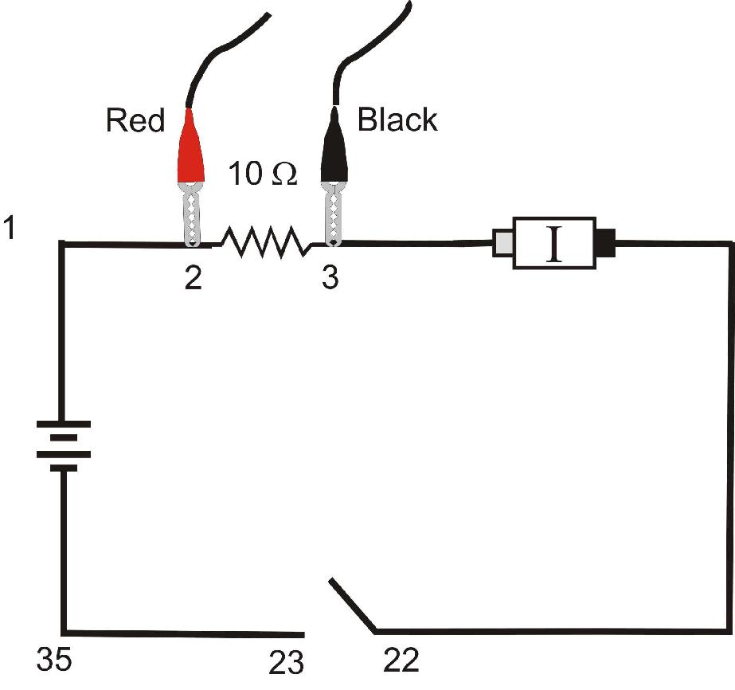
Figure 1

OBJECTIVES
- Determine the mathematical relationship between current, potential difference, and resistance in a simple circuit.
- Compare the potential vs. current behavior of a resistor to that of a light bulb.

MATERIALS
computer | Vernier Circuit Board, or
Vernier computer interface | wires
Logger Pro | clips to hold wires
one Vernier Current Probe and | switch
one Vernier Differential Voltage Probe | two resistors (about 10 and 50 Ω)
adjustable 5 volt DC power supply | light bulb (6.3 V)

PRELIMINARY SETUP AND QUESTIONS
1. Connect the Current Probe to Channel 1 and the Differential Voltage Probe to Channel 2 of the computer interface.
2. Open the file “22 Ohms Law” in the Physics with Vernier folder. A graph of potential vs. current will be displayed. The meter displays potential and current readings.
3. With the power supply turned off, connect the power supply, 10 Ω resistor, wires, and clips as shown in Figure 1. Take care that the positive lead from the power supply and the red terminal from the Current & Voltage Probe are connected as shown in Figure 1. Note: Attach the red connectors electrically closer to the positive side of the power supply.
4. Click 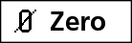. A dialog box will appear. Click  to zero both sensors. This sets the zero for both probes with no current flowing and with no voltage applied.
5. Have your teacher check the arrangement of the wires before proceeding. Turn the control on the DC power supply to 0 V and then turn on the power supply. Slowly increase the voltage to 5 V. Monitor the meter in Logger Pro and describe what happens to the current through the resistor as the potential difference across the resistor changes. If the voltage doubles, what happens to the current? What type of relationship do you believe exists between voltage and current?
PROCEDURE
1. Record the value of the resistor in the data table.
2. Make sure the power supply is set to 0 V. Click  to begin data collection. Monitor the voltage and current. Click 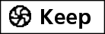.
3. Increase the voltage on the power supply to approximately 0.5 V. Click .
4. Increase the voltage by about 0.5 V. Click . Repeat this process until you reach a voltage of 5.0 V.
5. Click  and set the power supply back to 0 V.
6. Print a copy of the graph. Are the voltage and current proportional? Click the Linear Fit button, 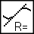. Record the slope and y-intercept of the regression line in the data table, along with their units.
7. Repeat Steps 1 – 6 using a different resistor.
8. Replace the resistor in the circuit with a 6.3 V light bulb. Repeat Steps 2–5, but this time increase the voltage in 0.1 V steps up to 5.0 V.
9. To compare slopes of data at different parts of the curve, first click and drag the mouse over the first 3 data points. Click the Linear Fit button, , and record the slope of the regression line in the data table. Be sure to enter the units of the slope.
10. Click and drag the mouse over the last 10 points on the graph. Click the Linear Fit button, , and record the slope of the regression line in the data table.
DATA TABLE
 | Slope of regression line (V/A) | Y-intercept of regression line (V)
Resistor Ω
Resistor Ω
Light bulb (first 3 pts)
Light bulb (last 10 pts)

ANALYSIS
1. As the potential across the resistor increased, the current through the resistor increased. If the change in current is proportional to the voltage, the data should be in a straight line and it should go through zero. In these two examples how close is the y-intercept to zero? Is there a proportional relationship between voltage and current? If so, write the equation for each run in the form potential = constantcurrent. (Use a numerical value for the constant.)
2. Compare the constant in each of the above equations to the resistance of each resistor.
3. Resistance, R, is defined using R = V/I where V is the potential across a resistor, and I is the current. R is measured in ohms (Ω), where 1 Ω = 1 V/A. The constant you determined in each equation should be similar to the resistance of each resistor. However, resistors are manufactured such that their actual value is within a tolerance. For most resistors used in this lab, the tolerance is 5% or 10%. Check with your instructor to determine the tolerance of the resistors you are using. Calculate the range of values for each resistor. Does the constant in each equation fit within the appropriate range of values for each resistor?
4. Do your resistors follow Ohm’s law? Base your answer on your experimental data.
5. Describe what happened to the current through the light bulb as the potential increased. Was the change linear? Since the slope of the linear regression line is a measure of resistance, describe what happened to the resistance as the voltage increased. Since the bulb gets brighter as it gets hotter, how does the resistance vary with temperature?
6. Does your light bulb follow Ohm’s law? Base your answer on your experimental data.
EXTENSIONS
1. Investigate Ohm’s law for reverse currents in resistors. Turn off the power supply and reverse the connections on the power supply. Turn the power supply back on and take data from 5.0 V to 0 V. Do not stop data collection. Turn off the power supply, restore the connections to the circuit to their original configuration, and turn the power supply back on. Take data from 0 to 5 V as before. Is the current still proportional to the potential across the resistor?
2. Investigate the behavior of other electrical devices such as diodes, LEDs, and Zener diodes. Make one run, then reverse the direction of the device and repeat.
3. Use a low voltage AC power supply and measure current and voltage as a function of time in a simple circuit. Compare the two graphs. Create a graph of voltage vs. current. Perform a linear regression over this data and compare to the resistance in the circuit.

