Newton’s Third Law
You may have learned this statement of Newton’s third law: “To every action there is an equal and opposite reaction.” What does this sentence mean?
Unlike Newton’s first two laws of motion, which concern only individual objects, the third law describes an interaction between two bodies. For example, what if you pull on your partner’s hand with your hand? To study this interaction, you can use two Force Sensors. As one object (your hand) pushes or pulls on another object (your partner’s hand) the Force Sensors will record those pushes and pulls. They will be related in a very simple way as predicted by Newton’s third law.
The action referred to in the phrase above is the force applied by your hand, and the reaction is the force that is applied by your partner’s hand. Together, they are known as a force pair. This short experiment will show how the forces are related.
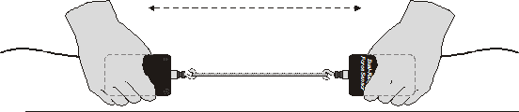
Figure 1
OBJECTIVES
- Observe the directional relationship between force pairs.
- Observe the time variation of force pairs.
- Explain Newton’s third law in simple language.

MATERIALS
computer | 500 g mass
Vernier computer interface | string
Logger Pro | rubber band
two Vernier Force Sensors
or two WDSS

PRELIMINARY QUESTIONS
1. You are driving down the highway and a bug splatters on your windshield. Which is greater: the force of the bug on the windshield, or the force of the windshield on the bug?
2. Hold a rubber band between your right and left hands. Pull with your left hand. Does your right hand experience a force? Does your right hand apply a force to the rubber band? What direction is that force compared to the force applied by the left hand?
3. Pull harder with your left hand. Does this change any force applied by the right hand?
4. How is the force of your left hand, transmitted by the rubber band, related to the force applied by your right hand? Write a rule, in words, for the force relationship.
PROCEDURE
1. Connect the two Dual-Range Force Sensors to Channels 1 and 2 of the interface. Set the range switch to 50 N.
2. Open the file “11 Newton’s Third Law” in the Physics with Vernier folder.
3. Force Sensors measure force only along one direction; if you apply a force along another direction, your measurements will not be meaningful. The Dual Range Force Sensor responds to force directed parallel to the long axis of the sensor.
4. (Optional)Since you will be comparing the readings of two different Force Sensors, it is important that they both read force accurately. In other words, it is set to calibrate them. To calibrate the first sensor,
- Choose Calibrate from the Experiment menu. Select CH1: Dual Range Force. Click on the  button.
- Remove all force from the first sensor and hold it vertically with the hook pointed down. Enter a 0 (zero) in the Value 1 field, and after the reading shown for Reading 1 is stable, click . This defines the zero force condition.
- Hang the 500 g mass from the sensor. This applies a force of 4.9 N. Enter 4.9 in the Value 2 field, and after the reading shown for Reading 2 is stable, then click .
- Click  to complete the calibration of the first Force Sensor.
- Repeat the process for the second Force Sensor.

5. You will be using the sensors in a different orientation than that in which they were calibrated. Zero the Force Sensors to account for this. Hold the sensors horizontally with no force applied, and click . Make sure both sensors are highlighted in the Zero Sensor Calibrations box and click  to zero both sensors. This step makes both sensors read exactly zero when no force is applied.
6. Click  to take a trial run of data. Pull on each Force Sensor and note the sign of the reading. Use this to establish the positive direction for each sensor. For this activity it is helpful to set up the two Force Sensors differently, since later you will have the sensors positioned so that a force to the left will generate the same sign of force on each sensor.
7. Make a short loop of string with a circumference of about 30 cm. Use it to attach the hooks of the Force Sensors. Hold one Force Sensor in your hand and have your partner hold the other so you can pull on each other using the string as an intermediary.
8. Click to begin collecting data. Gently tug on your partner’s Force Sensor with your Force Sensor, making sure the graph does not go off scale. Also, have your partner tug on your sensor. You will have 10 seconds to try different pulls. Choose Store Latest Run from the Experiment menu.
9. What would happen if you used the rubber band instead of the string? Would some of the force get “used up” in stretching the band? Use the prediction tool to sketch a prediction graph, and repeat Steps 7–8 using the rubber band instead of the string.
ANALYSIS
1. Examine the two data runs. What can you conclude about the two forces (your pull on your partner and your partner’s pull on you)? How are the magnitudes related? How are the signs related?
2. How does the rubber band change the results—or does it change them at all?
3. While you and your partner are pulling on each other’s Force Sensors, do your Force Sensors have the same positive direction? What impact does your answer have on the analysis of the force pair?
4. Is there any way to pull on your partner’s Force Sensor without your partner’s Force Sensor pulling back? Try it.
5. Reread the statement of the third law given at the beginning of this activity. The phrase equal and opposite must be interpreted carefully, since for two vectors to be equal (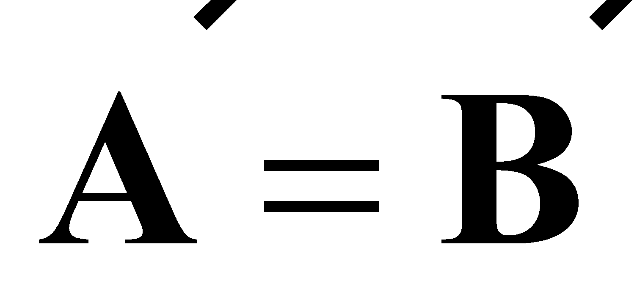) and opposite (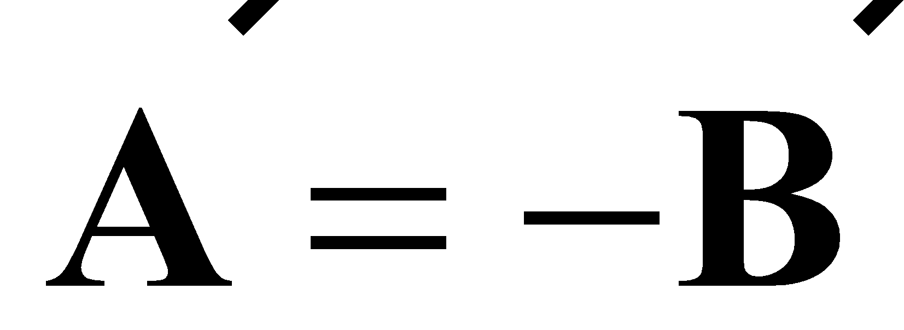) then we must have 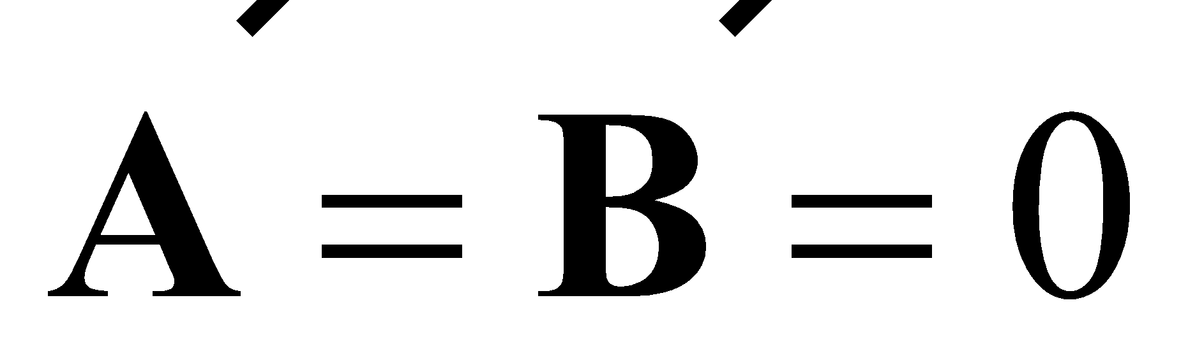; that is, both forces are always zero. What is really meant by equal and opposite? Restate Newton’s third law in your own words, not using the words “action,” “reaction,” or “equal and opposite.”
6. Re-evaluate your answer to the bug-windshield question.
EXTENSIONS
1. Fasten one Force Sensor to your lab bench and repeat the experiments. Does the bench pull back as you pull on it? Does it matter that the second Force Sensor is not held by a person?
2. Use a rigid rod to connect your Force Sensors instead of a string and experiment with mutual pushes instead of pulls. Repeat the experiments. Does the rod change the way the force pairs are related?

