Bungee Jump Accelerations
In this experiment, you will investigate the accelerations that occur during a bungee jump. The graph below records the acceleration vs. time for an actual bungee jump, where the jumper jumped straight upward, then fell vertically downward. The positive direction on the graph is upward.
For about the first 2 seconds, the jumper stands on the platform in preparation for the jump. At this point the acceleration is 0 m/s2. In the next short period of time, the jumper dips downward then pushes upward, both accelerations showing up on the graph. Between about 2.5 seconds and 4.5 seconds, the jumper is freely falling and the acceleration is near – 9.8 m/s2.
When all of the slack is out of the bungee cord, the acceleration begins to change. As the bungee cord stretches, it exerts an upward force on the jumper. Eventually the acceleration is upward although the jumper is still falling. A maximum positive acceleration corresponds to the bungee cord being extended to its maximum.
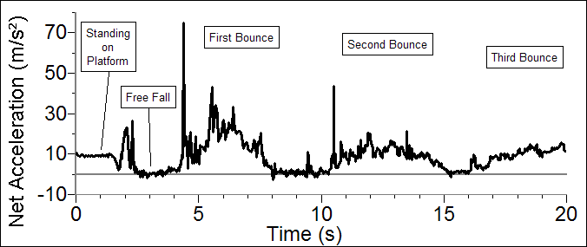
Figure 1
In your experiment, a block of wood or a toy doll will substitute for the jumper, and a rubber band will substitute for the bungee cord. An Accelerometer connected to the “jumper” will be used to monitor the accelerations.
OBJECTIVES
- Use an Accelerometer to analyze the motion of a bungee jumper from just prior to the jump through a few oscillations after the jump.
- Determine where in the motion the acceleration is at a maximum and at a minimum.
- Compare the laboratory jump with an actual bungee jump.
MATERIALS
computer | bungee jumper (wooden block or small doll)
Vernier computer interface | bungee cord (long, flexible rubber band)
Logger Pro | ring stand
Vernier Low-g Accelerometer or WDSS
PRELIMINARY QUESTIONS
1. Think about the forces acting on the bungee jumper at the lowest point of the jump. Draw a free-body diagram indicating the forces acting on the jumper. The force vectors with greater magnitude should be represented by longer arrows. Label the force vectors.
2. Study the graph of the acceleration during an actual bungee jump (Figure 1). On the graph, label the time corresponding to the lowest position during the jump.
3. What was the acceleration at that point? Was the direction of the acceleration up or down?
4. Label the time where the jumper reached the highest position during the first bounce.
5. What was the magnitude of the acceleration at that time? Was the direction of the acceleration up or down?
6. How long was the bungee cord used in the real bungee jump? Hint: Consider how long the jumper fell before the cord started pulling on him.
PROCEDURE
Part I The Jump–Step by Step
1. Connect the Vernier Low-g Accelerometer to Channel 1 of the interface. Attach a block of wood or small doll (your jumper) to the Accelerometer. The arrow on the Accelerometer should be pointing upward (toward the hook if using a block, or toward the feet of the doll).  2. Tie the rubber band to the hook on the wooden block or to the feet of the doll. Tie the other end of the rubber band to a rigid support, such as a large ring stand. Adjust the length of the cord so that the block or doll does not hit the floor when dropped. | 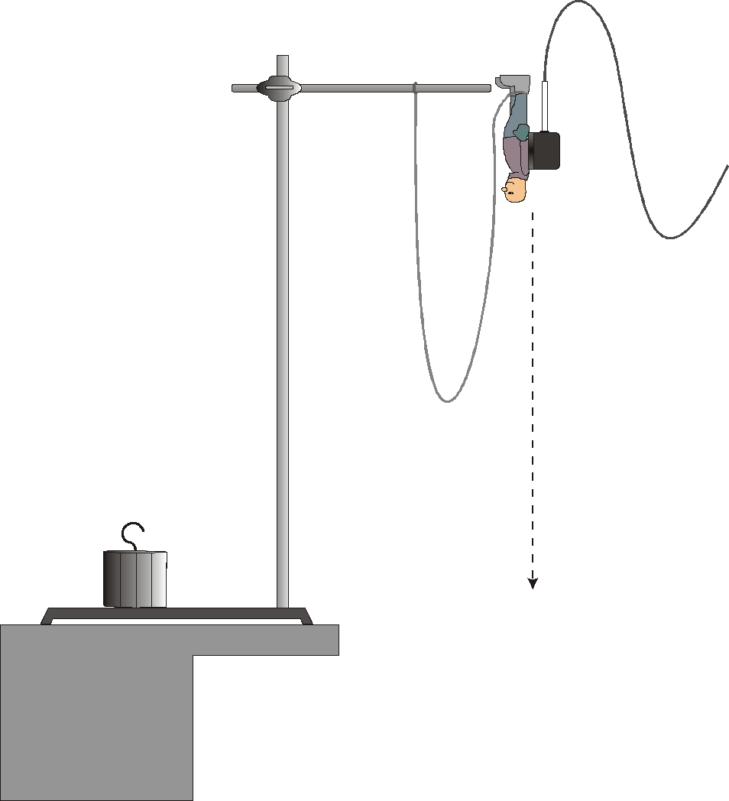
3. Open the file “07 Bungee Jump” in the Physics with Vernier folder. The Accelerometer is calibrated so that it reads, only for the vertical direction, zero acceleration when at rest and –9.8 m/s2 when in free fall. You will do this in Steps 5 and 6.
4. Hold the bungee jumper stationary on the table, with the Accelerometer arrow pointing up. Click  to define the state as zero acceleration.
5. Click  to begin collecting data. Do not release the jumper. When data collection has finished, select a region of the graph by dragging the mouse pointer across it. Determine the mean (average) acceleration by clicking the Statistics button, 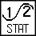. It should be near zero. This value represents the acceleration of the jumper prior to jumping.
6. Repeat Step 5, but this time drop the jumper and let it free fall. Make sure it is oriented properly (arrow pointed up). Catch the jumper while the cord is still slack. Determine the average acceleration during the fall. It should be close to –9.8 m/s2.
7. Let the jumper hang from the bungee cord. Pull the jumper down 5 cm and release the jumper, creating an up-and-down oscillation similar to a mass suspended from a vibrating spring. Click and observe the graph. Determine the point in the motion where acceleration is both positive in direction and has a maximum magnitude. Does this occur when the jumper is at the bottom, middle, or top of the oscillation?
Part II A Complete Jump
8. Lift the bungee jumper to the height of the ring stand, as shown in Figure 2. The bungee cord should be hanging to the side and the Accelerometer cable should be clear of the jump path. Make sure that the Accelerometer arrow is pointing up. The connection point between the bungee cord and the jumper should also be pointing upward.
9. Click to start collecting data. Wait 1 s and release the bungee jumper so that it falls straight down with a minimum of rotation. Let the jumper bounce a few times. Be sure that the Accelerometer cable still has some slack when the jumper reaches the lowest point.
10. Repeat the measurement until you have a satisfactory set of data. A successful run should include a minimum of rotation, a section of free fall before the cord starts to pull on the jumper, and a few bounces, with at least the first bounce high enough to cause the cord to again go slack. The acceleration vs. time graph for the laboratory jump should show features similar to the graph of the real bungee jump. Print or sketch your final graph.
DATA TABLE
Time (s) | Acceleration (m/s2) | Direction of motion  (up or down)

ANALYSIS
1. Examine the data by clicking the Examine button, 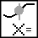, and move the mouse to determine the acceleration at eight different points on the graph. Make sure that you choose points during the initial rest, free fall, when the cord is taut, and several bounces. Indicate the direction of the motion using up, down or at rest.
2. Perform the same analysis on your bungee jump as was done on the real bungee jump in the Preliminary Questions section.
3. How well does the laboratory jump compare with the real jump? Discuss the similarities and differences.
4. How could you improve the correlation between the lab jump and the real jump?
EXTENSIONS
1. Place a Motion Detector on the floor during a jump. Examine the Motion Detector data (position vs. time and velocity vs. time graphs) of the jump. How do these data compare to the Accelerometer data? Which sensor do you think is a better tool for the analysis of the jump? Explain.
2. Capture the laboratory bungee jump or a real bungee jump on video. View the video tape and match the Accelerometer graph with the video of the jump.
3. Repeat the experiment with a jumper of different mass. What are the similarities and differences between the two sets of data? Discuss some methods that might be used by operators of commercial bungee jumps to assure the safety of jumpers of different weights.
4. Connect the bungee cord to a Force Sensor to examine the bungee cord tension during the jump.
5. Use reference books or the Internet to find a reference that documents the accelerations experienced by the Shuttle astronauts during takeoff and re-entry. How do the accelerations experienced by the astronauts compare to the maximum acceleration experienced by a bungee jumper?

