Pendulum Periods
A swinging pendulum keeps a very regular beat. It is so regular, in fact, that for many years the pendulum was the heart of clocks used in astronomical measurements at the Greenwich Observatory.
There are at least three things you could change about a pendulum that might affect the period (the time for one complete cycle):

- the amplitude of the pendulum swing
- the length of the pendulum, measured from the center of the pendulum bob to the point of support
- the mass of the pendulum bob

To investigate the pendulum, you need to do a controlled experiment; that is, you need to make measurements, changing only one variable at a time. Conducting controlled experiments is a basic principle of scientific investigation.
In this experiment, you will use a Photogate capable of microsecond precision to measure the period of one complete swing of a pendulum. By conducting a series of controlled experiments with the pendulum, you can determine how each of these quantities affects the period.
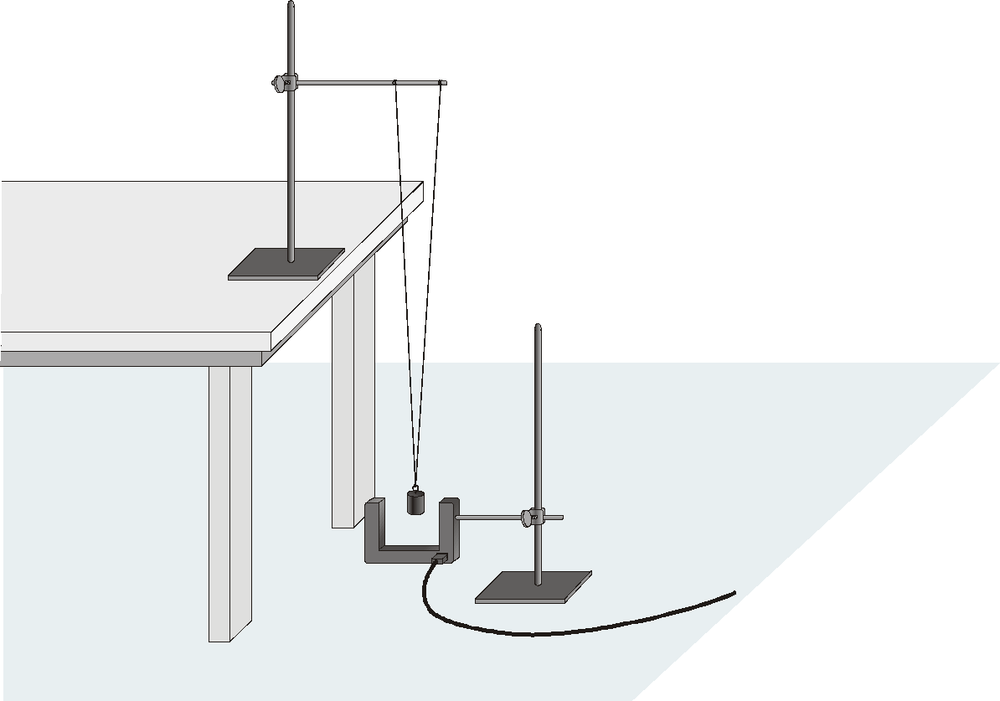
Figure 1

OBJECTIVES
- Measure the period of a pendulum as a function of amplitude.
- Measure the period of a pendulum as a function of length.
- Measure the period of a pendulum as a function of bob mass.

MATERIALS
computer | string
Vernier computer interface | 2 ring stands and pendulum clamp
Logger Pro | masses of 100 g, 200 g, 300 g
Vernier Photogate | meter stick
protractor
PRELIMINARY QUESTIONS
1. Make a pendulum by tying a 1 m string to a mass. Hold the string in your hand and let the mass swing. Observing only with your eyes, does the period depend on the length of the string? Does the period depend on the amplitude of the swing?
2. Try a different mass on your string. Does the period seem to depend on the mass?
PROCEDURE
1. Use the ring stand to hang the 200 g mass from two strings. Attach the strings to a horizontal rod about 10 cm apart, as shown in Figure 1. This arrangement will let the mass swing only along a line, and will prevent the mass from striking the Photogate. The length of the pendulum is the distance from the point on the rod halfway between the strings to the center of the mass. The pendulum length should be at least 1 m.
2. Attach the Photogate to the second ring stand. Position it so that the mass blocks the Photogate while hanging straight down. Connect the Photogate to DIG/SONIC 1 on the interface.
3. Open the file “14 Pendulum Periods” in the Physics with Vernier folder. A graph of period vs. time is displayed.
4. Temporarily move the mass out of the center of the Photogate. Notice the reading in the status bar of Logger Pro at the bottom of the screen, which shows when the Photogate is blocked. Block the Photogate with your hand; note that the Photogate is shown as blocked. Remove your hand, and the display should change to unblocked. Click  and move your hand through the Photogate repeatedly. After the first blocking, Logger Pro reports the time interval between every other block as the period. Verify that this is so.
5. Now you can perform a trial measurement of the period of your pendulum. Pull the mass to the side about 10º from vertical and release. Click and measure the period for five complete swings. Click . Click the Statistics button, 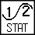, to calculate the average period. You will use this technique to measure the period under a variety of conditions.
Part I Amplitude
6. Determine how the period depends on amplitude. Measure the period for five different amplitudes. Use a range of amplitudes, from just barely enough to unblock the Photogate, to about 30º. Each time, measure the amplitude using the protractor so that the mass with the string is released at a known angle. Repeat Step 5 for each different amplitude. Record the data in your data table.
Part II Length
7. Use the method you learned above to investigate the effect of changing pendulum length on the period. Use the 200 g mass and a consistent amplitude of 20º for each trial. Vary the pendulum length in steps of 10 cm, from 1.0 m to 0.50 m. If you have room, continue to a longer length (up to 2 m). Repeat Step 5 for each length. Record the data in the second data table below. Measure the pendulum length from the rod to the middle of the mass.

Part III Mass
8. Use the three masses to determine if the period is affected by changing the mass. Measure the period of the pendulum constructed with each mass, taking care to keep the distance from the ring stand rod to the center of the mass the same each time, as well as keeping the amplitude the same. Repeat Step 5 for each mass, using an amplitude of about 20°. Record the data in your data table
DATA TABLE
Part I Amplitude
Amplitude | Average period
(°) | (s)

Part II Length
Length | Average period
(cm) | (s)

Part III Mass
Mass | Average period
(g) | (s)
100
200
300

ANALYSIS
1. Why is Logger Pro set up to report the time between every other blocking of the Photogate? Why not the time between every block?
2. Use Logger Pro to plot a graph of pendulum period vs. amplitude in degrees. Scale each axis from the origin (0,0). Does the period depend on amplitude? Explain.
3. Plot a graph of pendulum period T vs. length . Scale each axis from the origin (0,0). Does the period appear to depend on length?
4. Plot the pendulum period vs. mass. Scale each axis from the origin (0,0). Does the period appear to depend on mass? Do you have enough data to answer conclusively?
5. To examine more carefully how the period T depends on the pendulum length , create the following two additional graphs of the same data: T 2 vs.  and T vs.  2. Of the three period-length graphs, which is closest to a direct proportion; that is, which plot is most nearly a straight line that goes through the origin?
6. Using Newton’s laws, we could show that for some pendulums, the period T is related to the length  and free-fall acceleration g by
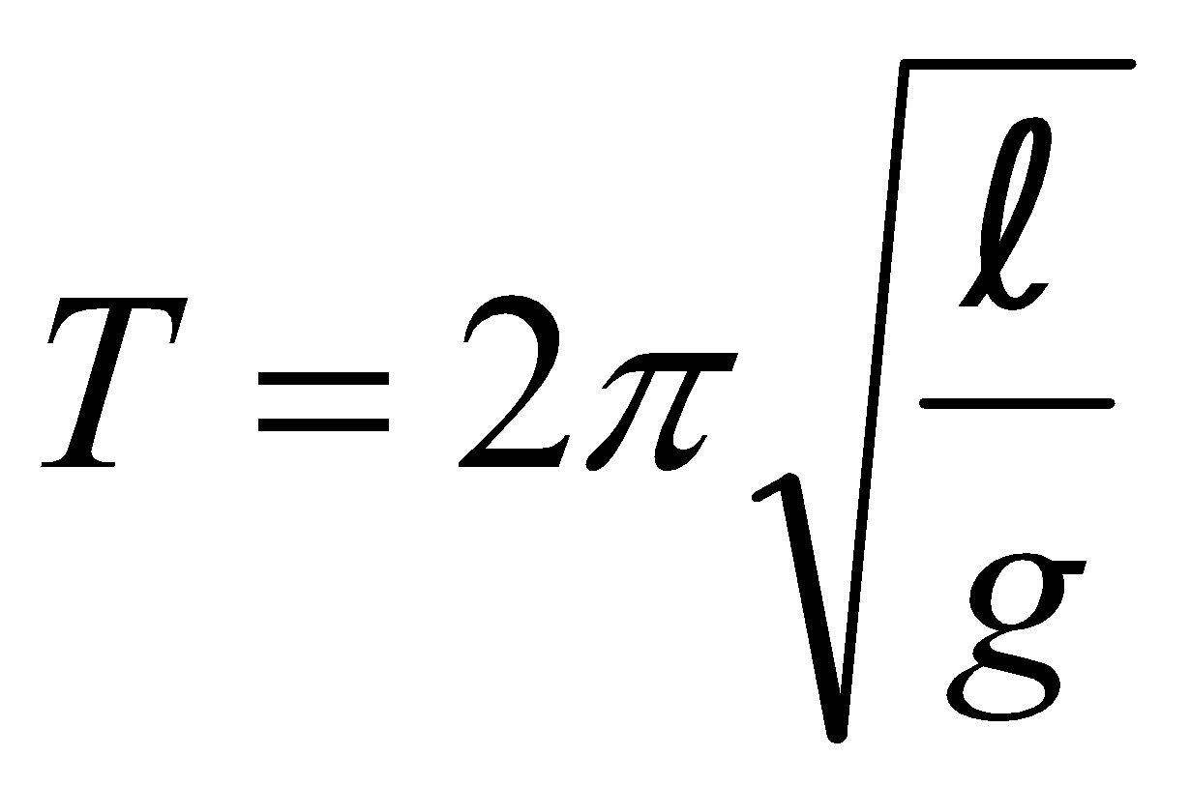, or 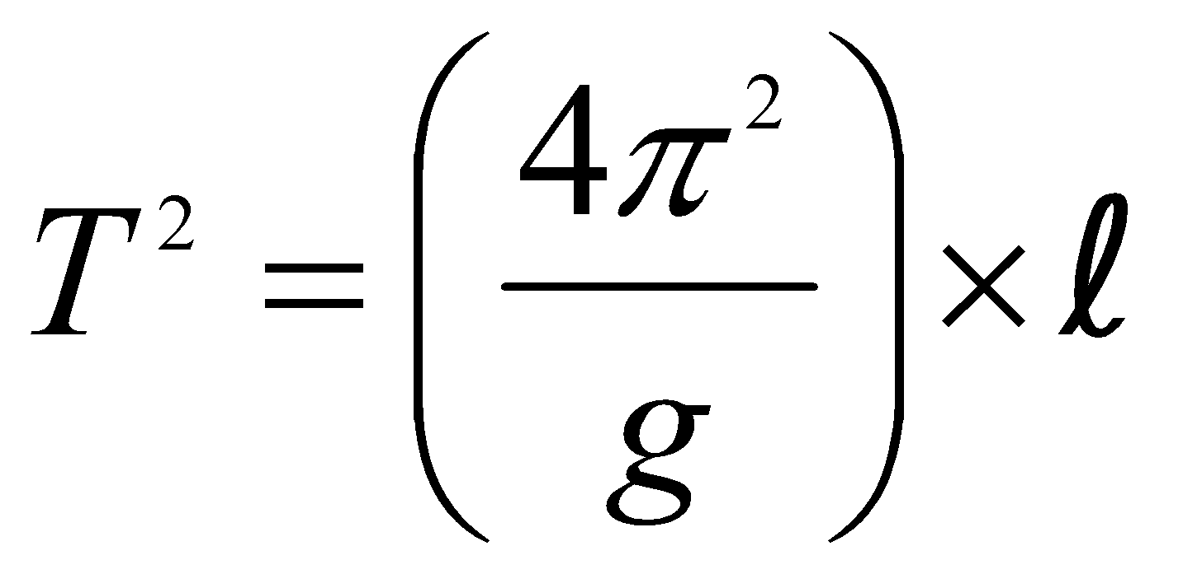
Does one of your graphs support this relationship? Explain. (Hint: Can the term in parentheses be treated as a constant of proportionality?)
EXTENSIONS
1. From your graph of T 2 vs.  determine a value for g.
2. Given what you observed in this experiment, write a set of rules for constructing a pendulum clock that is reliable under a variety of temperatures.
3. Try a larger range of amplitudes than you used in Part I. If you did not see a change in period with amplitude before, you should now. Check a college physics textbook for an expression for the period of a pendulum at large amplitudes and compare to your own data.
4. Try a different method to study how the period of a pendulum depends on the amplitude. Start the pendulum swinging with a fairly large amplitude. Start data collection and allow data collection to continue for several minutes. The amplitude of the swing will gradually decrease and you can see how much the period changed.
5. Use an air table and air table puck as your pendulum. Tip the air table to a variety of angles, θ, and determine the relationship between the period and the angle.

