Speed of Sound
Compared to most things you study in the physics lab, sound waves travel very fast. It is fast enough that measuring the speed of sound is a technical challenge. One method you could use would be to time an echo. For example, if you were in an open field with a large building a quarter of a kilometer away, you could start a stopwatch when a loud noise was made and stop it when you heard the echo. You could then calculate the speed of sound.
To use the same technique over short distances, you need a faster timing system, such as a computer. In this experiment you will use this technique with a Microphone connected to a computer to determine the speed of sound at room temperature. The Microphone will be placed next to the opening of a hollow tube. When you make a sound by snapping your fingers next to the opening, the computer will begin collecting data. After the sound reflects off the opposite end of the tube, a graph will be displayed showing the initial sound and the echo. You will then be able to determine the round trip time and calculate the speed of sound.

Microphone

1 m tube

Closed end

Figure 1
OBJECTIVES
- Measure how long it takes sound to travel down and back in a long tube.
- Determine the speed of sound.
- Compare the speed of sound in air to the accepted value.

MATERIALS
computer | tube, 1-2 meters long
Vernier computer interface | book or plug to cover end of tube
Logger Pro | thermometer or temperature probe
Vernier Microphone | meter stick or tape measure
dog training clicker

PRELIMINARY QUESTION
1. A common way to measure the distance to lightning is to start counting, one count per second, as soon as you see the flash. Stop counting when you hear the thunder and divide by five to get the distance in miles. Use this information to estimate the speed of sound in m/s.

PROCEDURE
1. Connect the Vernier Microphone to Channel 1 of the interface.
2. Use a thermometer or temperature probe to measure the air temperature of the classroom and record the value in the data table.
3. Open the file “33 Speed of Sound” in the Physics with Vernier folder. A graph of sound level vs. time will be displayed.
4. Close the end of the tube. This can be done by inserting a plug or standing a book against the end so it is sealed. Measure and record the length of the tube in your data table.
5. Place the Microphone as close to the end of the long tube as possible, as shown in Figure 2. Position it so that it can detect the initial sound and the echo coming back down the tube.
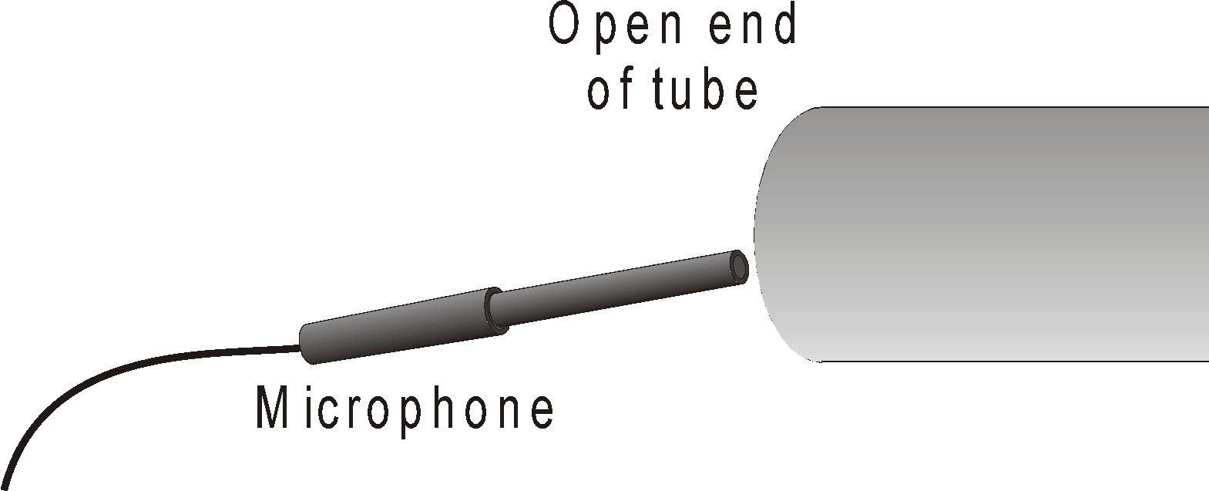
Figure 2

6. Click  to begin data collection. Click the dog training clicker near the opening of the tube. This sharp sound will trigger the interface to begin collecting data.
7. If you are successful, the graph will resemble the one below. Repeat your run if necessary. The second set of vibrations with appreciable amplitude marks the echo. Click the Examine button, 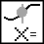. Move the mouse and determine the time interval between the start of the first vibration and the start of the echo vibration. Record this time interval in the data table.
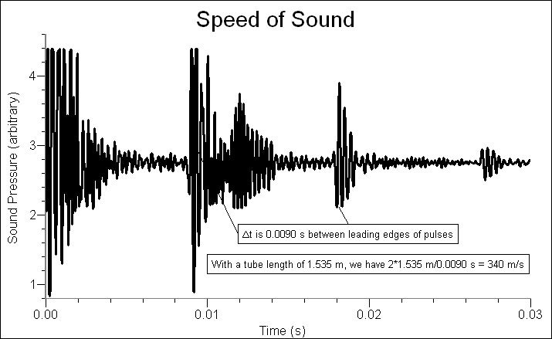

8. Repeat the measurement for a total of five trials and determine the average time interval.
DATA TABLE
Length of tube | m
Temperature of room | °C

Trial | Total travel time (s)
1
2
3
4
5
Average
Speed | m/s
ANALYSIS
- From the time-pairs you recorded in the data table, calculate the differences to find the time interval, and then calculate the average time interval.
2. Calculate the speed of sound. Remember that your time interval represents the time for sound to travel down the tube and back.
3. The accepted speed of sound at atmospheric pressure and 0C is 331.5 m/s. The speed of sound increases 0.607 m/s for every C. Calculate the speed of sound at the temperature of your room and compare your measured value to the accepted value.
EXTENSIONS
1. Repeat this experiment, but collect data with a tube with an open end. How do the reflected waves for the closed-end tube compare to the reflections with an open-end tube? It might be easier to see any changes by striking a rubber stopper held next to the opening instead of snapping your fingers. Explain any differences. Calculate the speed of sound and compare it to the results with a tube with a closed end.
2. This experiment can be performed without a tube. You need an area with a smooth surface. Multiple reflections may result (floor, ceiling, windows, etc.), adding to the complexity of the recorded data.
3. Fill a tube with another gas, such as carbon dioxide or helium. Be sure to flush the air out with the experimental gas. For heavier-than-air gases, such as carbon dioxide, orient the tube vertically and use a sealed lower end. Invert the tube for lighter-than-air gases.
4. Use this technique to measure the speed of sound in air at different temperatures.
5. Develop a method for measuring the speed of sound in a medium that is not a gas.

